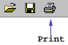
M&IS 24053: Computer Applications
Summer II 2003

Dr. Jay Weinroth
Office hours: Tues, Thurs, 5:30 - 6:30 p.m
Office -- thru June 30 -- A432 -- phone 330 672-1141
Beginning July 1 -- A421 -- phone 672-1150
jweinrot@bsa3.kent.edu

M&IS 24053: Computer Applications
Course Theme
Solving information related problems using computers, networks, software and data.


M&IS 24053: Computer Applications
Course Objectives
The fundamental objective is for you to develop an appreciation for the contribution that computers and software can make to your life as a student and as a professional. It is expected that during this term you will develop competency in the operation of the hardware and software to which you are exposed. It is further expected that as you master the course material your confidence in your ability will increase.A secondary objective is for this to be an enjoyable and fun learning experience.


M&IS 24053: Computer Applications
Textbook and Other Materials
The course's text book is Computers and Information Systems, Steinberg, Geoffrey, Paperclip Productions
Most of the text's material will be covered. Use the course's weekly schedule as a guide so that you read the appropriate chapters before that material is covered in class. You should read the material before coming to class so that you are ready to participate in the class discussion.

Class Slide Presentations
Copies of the instructor's classroom slide presentations are included with the textbook. You will find these copies very handy when you take class notes. The textbook has exact images of most of the slides used by the instructor. Take your notes directly on the copies. It will make note taking easier and more accurate. You will find it easier to study for quizzes too.

Class Notes
The textbook provides pages for your class note taking. You are encouraged to use these pages so that your notes, the text material and the classroom slides are kept together. This too will help you master the material and prepare for quizzes.

Floppy Disk
You should use the floppy disk which is packaged with the book. Although not required, you may wish to purchase a 3.5" floppy disk to use for backing up your homework.

M&IS 24053: Computer Applications
Orion
Many of your course activities are interactive and involve using the Orion server. Quizzes and homework are administered and graded by Orion.

Follow these steps to log on to Orion:
- Start a web browser. You must use Internet Explorer. (Some ORION functions do not operate in Netscape due to security considerations.)
- Go to this web address: http://orion.kent.edu
- Select this option:
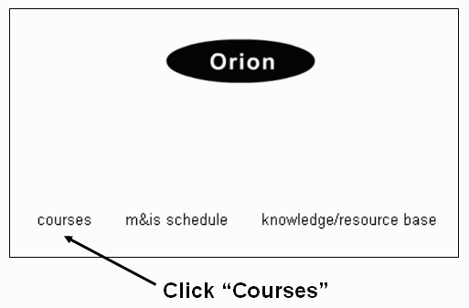
- Enter your log on information:
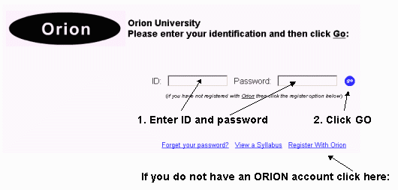

M&IS 24053: Computer Applications
Homework
There are 11 regular assignments. Each assignment is worth 1 or two points toward your total semester grade. To view specifics about assignments use your ID and password to log on to Orion and use the option shown below:
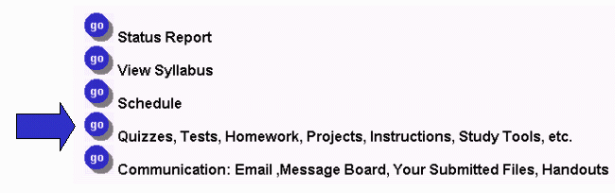
• All regular assignments are graded automatically by the Orion System.
• Each regular assignment must be completed by the due date.
• You may submit any regular assignment three times until the due date.
• The grade on record at the due date is your grade.

Schedule
The schedule (available from your Orion menu - see above) shows you the homework and extra credit due dates.

Submitting Regular Assignments
You will complete most of your regular assignments using a disk such as the one included with the text. To submit regular assignments use the "Quizzes, tests ..." option from your personal Orion System menu (see above).

Grade Status
Each time a regular assignment is graded a fresh copy of your grade status report will be put on the Internet for you to access. See menu above for access to status report.

M&IS 24053: Computer Applications
Extra Credit
There are 5 extra-credit assignments and 2 extra-credit surveys. All together you may earn up to six points of extra credit. To view specifics about assignments use your ID and password to log on to Orion and use the option shown below:
• Each extra-credit assignment and survey is graded automatically by the Orion System.
• Each must be completed by the due date.
• Extra-credit assignment and survey may be submitted only once.
• Each extra-credit assignment and survey is worth up to 1 point added to your final course average.

Schedule
The schedule (available from your Orion menu - see above) shows you the homework and extra credit due dates.

Submitting Extra-Credit Assignments
You will complete most of your extra-credit assignments using a disk such as the one included with the text. To submit extra-credit assignments use the "Quizzes, tests ..." option from your personal Orion System menu (see above).

Grade Status
Each time an extra-credit assignment is graded a fresh copy of your grade status report will be put on the Internet for you to access. See menu above for access to status report.

M&IS 24053: Computer Applications
Quizzes
- There are 8 short objective quizzes through the semester. The schedule (available from your Orion menu - see illustration below) shows you the quiz due dates.
- Each quiz score is computed as a percent correct. (a perfect score is 100% )
- Each quiz is worth 11 points toward your total semester grade. If you score 100% on a quiz then you earn all 11 points. If you score less than 100% the points earned are adjusted accordingly.
- Each quiz is curved up to an average of 75% if necessary. Averages are not curved down! This means that if the class average is 72 then 3 points are added to eveyone's quiz score to bring the average up to 75.
- Each quiz is administered during a quiz period. Each quiz period is one week (weekdays only).
- You take the quiz in the College of Business Computer Lab (2nd floor) at any time during the week when a quiz proctor is in the lab. You must begin a quiz at least 60 minutes before the end of a quiz period.
- Each quiz is a self-contained unit. That means that the quizzes are not comprehensive. Each quiz contains material covered in class during the two weeks prior to the beginning of the quiz period (the first Quiz is an exception - it covers just one week).
- There is no final exam. The 8th quiz is also non-comprehensize and is taken during finals week.
- Quizzes are open notes and you are permitted to use other software while taking a quiz. You are not permitted to discuss anything with anyone while taking a quiz - violations are grounds for receiving a grade of 0 for the quiz in progress.

Taking a Quiz
You may not begin any quiz until you demonstrate your understanding of the syllabus. You must do this by completing the Syllabus Contract.
Once you have successfully completed the Syllabus Contract you begin a quiz this way:
- Bring your student ID to the College of Business Computer Lab (2nd floor) during the quiz period.. No quiz may be started less than 60 minutes before a proctor is due to leave the lab.
- Log on to Orion and select the "Quizzes, tests, ..." option (see above).
- Select the quiz you want to take.
- Request that a proctor (look around the lab for one) check your id (name and picture). You may not begin a quiz without proper identification.

Study Tools
Study tools are available for each quiz. To view a study guide or try a practice quiz: Log on to Orion and select the "Quizzes, tests, ..." option (see above).

Viewing Results
Once a quiz period has ended you may view your quiz (all questions and answers) by locating the quiz in your status report.

M&IS 24053: Computer Applications
Syllabus Contract
This syllabus is a contract between you and the instructor. Your responsibilities are described in this document. Before you are permitted to attempt any of the course quizzes you must demonstrate that you understand the contract (syllabus) by earning a perfect scrore (100%) on a syllabus survey. Check the course schedule for the survey dates.
You are permitted to attempt the Syllabus Contract Survey as often as you like until you reach 100%. You may attempt the Survey from any Internet connected computer.
It is strongly suggested that you print this syllabus (use the Print All option) and use it while completing the survey.
To find the Syllabus Contract select the Orion menu option indicated below:

M&IS 24053: Computer Applications
Your Grade

Rules
- You semester grade is the weighted average of the 8 quizzes + 11 homework assignments.
- Each quiz and homework is to be completed on time by the due date. You receive no credit for quizzes or homeworks incomplete after the due date.
- Up to 5 points of extra credit may be added to your quiz and homework average. The 5 extra credit assignments have due dates as well.
- The Kent State grading scale is used:
90+ | 80-89 | 70-79 | 60-69 | 0-59
A | B | C | D | E
Grades are rounded, so 89.5 becomes an A.

Grading Example
Your grade is based on 8 quizzes (worth 11 points each) and 11 homeworks (worth 1 or 2 points each) and 5 extra credit assignments (worth 1 point each).
Here is an example of 8 quiz grades and 11 homework grades:
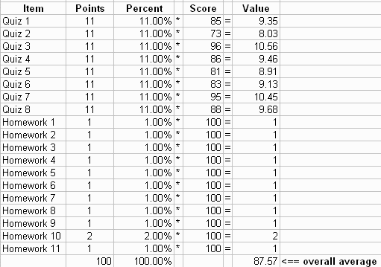
87.57 points would be a B grade. This grading scale is used:
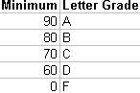

How extra credit works
If this student earned 2 extra credit points then a total of 89.57 points (87.57 + 2) was earned. The letter grade becomes A because grades are rounded (89.57 rounded to 90).

Important Notes:
- Grades are rounded (see above)
- On each quiz the final average for the class will always be at least 75. If the average is below 75 when all students have completed the quiz then the average will be increased to 75. If the average is at least 75 when all students have completed the quiz then the average is not changed. Quiz averages are never rounded down! Here is an example:
Suppose the class average for Quiz 3 is 70. To curve up to 75 each student is given 5 extra points for their individual Quiz 3 score. So if you received a Quiz 3 score of 72 then your score becomes 77 after the curve is applied.
- Final semester averages are not curved.

M&IS 24053: Computer Applications
Daily Class Schedule and Reading Assignments
• The daily schedule indicates the topics covered during each class session.
• For sections that meet once a week the Tuesday and Thursday material are covered in one class meeting.
• You are expected to complete the reading assignments (pages shown in ()) prior to each class meeting.
• The Quiz column indicates what quiz covers the material shown to the left.
Week | Tuesday | Thursday | Quiz #
1 | 6/10  introduction  data and information (1.1-1.15)  end of quiz 1 material | 6/12  windows (3.1-3.17)  windows & word (5.1-5.8) | 1
2 | 6/17  hardware (4.1-4.6)  software (4.6-4.11)  end of quiz 2 material | 6/19  excel- intro;functions & formulas (6.1-6.13)  excel -- other kinds of data/data menu (6.18-6.23 & 6.27-6.40) | 2 & 3
3 | 6/24  information systems (2.1-2.6)  end of quiz 3 material  email & communications (9.25-9.27 & 9.1-9.25) | 6/26  NO CLASS | 2 & 3
4 | 7/1  NO CLASS | 7/3  communications  graphics/power point (7.1-7.15 & Appendix A) | 4 & 5
5 | 7/8  power point  end of quiz 4 material  excel - cell addressing (6.45-6.58) | 7/10  excel - logic (6.64-6.69)  excel - linking spreadsheets (6.74)  end of quiz 5 material | 4 & 5
6 | 7/15  internet & HTML (10.1-10.19)  HTML (10.10-10.19) | 7/17  societal issues (11.1-11.7)  systems analysis (12.1-12.12)  end of quiz 6 material | 6 & 7
7 | 7/22  excel - merging tables (6.75-6.78)  excel - relationship between records (6.78-6.80) | 7/24  excel - charts (6.84-6.89)  excel - statistics (6.89-6.90)  end of quiz 7 material | 6 & 7
8 | 7/29  database - intro, single table operations (8.1-8.10)  database - database theory (8.34-8.36) | 7/31  database - creating a database/multi table joins (8.20-8.30 & 8.12-8.14)  end of quiz 8 material | 8

M&IS 24053: Computer Applications
Tutors and Proctors
Lab tutors are available to help you during certain hours each week. They can be found in the College of Business Computer Lab on the building's 2nd floor.
The tutors are also proctors for your quizzes. Bring your ID to the lab to take a quiz. You must present yourself to a proctor at least 60 minutes before the end of a quiz day to obtain permission to begin a quiz.
Tutors will be available in the College of Business computer lab (second floor) during the hours shown in the following table:

Monday | 10:30-9:00
Tuesday | 10:30-3:00  Quiz Week Only: 3:00-7:00
Wednesday | 10:30-9:00
Thursday | 10:30-9:00
Friday | 10:00-5:00
You may not begin a quiz less than one hour before the end of a quiz day.

M&IS 24053: Computer Applications
Rules
In order to be fair to all students the following rules are enforced:

Review of a Quiz Grade
You may ask the instructor to review any specific questions on any quiz or homework assignment. You must make the request not more than one week after the quiz pr assignment due date has passed. Requests after that deadline will be automatically rejected.

Computer Virus
WARNING!!! If you submit an assignment with a computer virus then you fail the course. No exceptions! It is your responsibility to ensure that your work is clean.

Excused lateness
The following are the only accepted excuses for late homework or permission to take a quiz late:
  - sickness with medical note
  - athletic event - with coach's note
  - religious observation
  - military responsibility with documentation
  - death in family with documentation

Lecture
You are expected to respect the other students! This means never ridicule anyone for asking a question. There is no such thing as a stupid question but it is stupid not to ask questions! Laughing at or ridiculing another student is grounds for dismisal from this course with a grade of F.

Cheating
Cheating is grounds for automatic failure in the course so don't do it! Cheating includes, but is not limited to, copying from another student during an exam, submitting the same homework as another student, and illegally copying (really stealing) software.Any voliation is grounds for dismisal from this course with a grade of F.

Respect
You are expected to act in a proper fashion at all times during the semester. Being respectful of other students and the instructor is essential. Behavior otherwise will not be tolerated and is ground for dismissal from the course at any time during the semester. Dismissal results in a grade of F.

Cell Phones and Pagers
Use of a cell phone or pager during class is grounds for removal from the class. Use of such equipment is rude and disrespectful towarde the instructor and other students (see respect above). Use of a cell phone or pager during class is ground for dismissal from this course with a grade of F.

Email
Emails that you send to the instructor should conform to normal rules of etiquette:

  - Sign your name to your messages. Failure to do so will result in the instructor not responding to you.
  - Do not type in all CAPITAL LETTERS. It is rude because it seems like you are shouting. The instructor will not respond.
  - Make your message clear and understandable. Type your message in bullet points rather than in a long jumbled paragraph. Do not make the instructor go on a treasure hunt while reading your message. Here is an example of a long jumbled message that would not be responded to:
"Hi. My name is _______ ________ and I am in your Computer Applications class on Tuesday and Thursday 915. I have a question regarding computer problems during a quiz. For quiz two my computer shut down during the middle of my quiz and I had to wait 10 minutes for a proctor to help me sign back on. On that day I had an appointment scheduled right after the quiz, just enough time for me to take the quiz and make it to my appointment. I was 15 minutes late to my appointment and didn't have enough time due to the computer problem. On quiz three I had saved two of the harder questions to last and was left with about 3 minutes for the last problem and had done all of the work in excel. I multiplied the two columns, subtotaled, then did a count so that I could divide by that number and still had about 2 minutes. After I did the count my mouse began to highlight everything everytime that I moved it. Once again I had to wait for a proctor while time was shortening on my quiz. There happened to be a problem with my mouse..."

M&IS 24053: Computer Applications
Etc.

Lecture
No early mass exodus from the lecture hall. If you plan to leave early then don't come to class. There are other students who want to be in class and it is not fair to disrupt them by the noise and disturbance of early departures.

Attendance
Attendance is not mandatory but it is strongly recommended. You are responsible for all material presented. It is not reasonable for you to ask for special consideration claiming that you miss material because you were not in class.

Students with Disabilities
In accordance with University policy, if you have a documented disability and require accomodations to obtain equal access in this course, please contact the instructor at the beginning of the semester or when given an assignment for which accomodation is required. Students with disabilities must verify their eligibility through the Office of Student Disability Services (SDS) in the Michael Schwartz Services Center (672-2972).

Thinking About a Major or Minor in IS?
Enrollment in the initial courses (24060 - Systems Analysis and 24070 Principles of System Development) requires permission. Click here for details.

